**A**

**Project Report**

**On**

**"Live Chat"**

(IT346 – Summer Internship-1)

**Prepared by**

Raj Banker(16IT003)

Chirag Patel(16IT065)

**Under the Supervision of**

Mr. Parvez Vanitya

**Submitted to**

Charotar University of Science & Technology (CHARUSAT)

for the Partial Fulfillment of the Requirements for the

Degree of Bachelor of Technology (B.Tech.)

in Information Technology (IT)

for 5th semester B. Tech

**Submitted at**



**Accredited with Grade A by NAAC**

**Accredited with Grade A by KCG**



**DEPARTMENT OF INFORMATION TECHNOLOGY**

**(NBA Accredited)**

**Chandubhai S. Patel Institute of Technology (CSPIT)**

**Faculty of Technology & Engineering (FTE), CHARUSAT**

**At: Changa, Dist: Anand, Pin: 388421.**

**June, 2018**

**DECLARATION BY THE CANDIDATE**

We hereby declare that the project report entitled “**Live Chat**” submitted by us to Chandubhai S. Patel Institute of Technology, Changa in partial fulfilment of the requirement for the award of the degree of **B.Tech** in Information Technology, from Department of Information Technology, CSPIT/FTE, is a record of bonafide **IT346 Summer Intership-1** carried out by us under the guidance of **Mr.** **Parvez Vanitya**. We further declare that the work carried out and documented in this project report has not been submitted anywhere else either in part or in full and it is the original work, for the award of any other degree or diploma in this institute or any other institute or university.

Raj Banker (16IT003)

Chirag Patel(16IT065)

Mr. Parvez Vantiya

General Manager

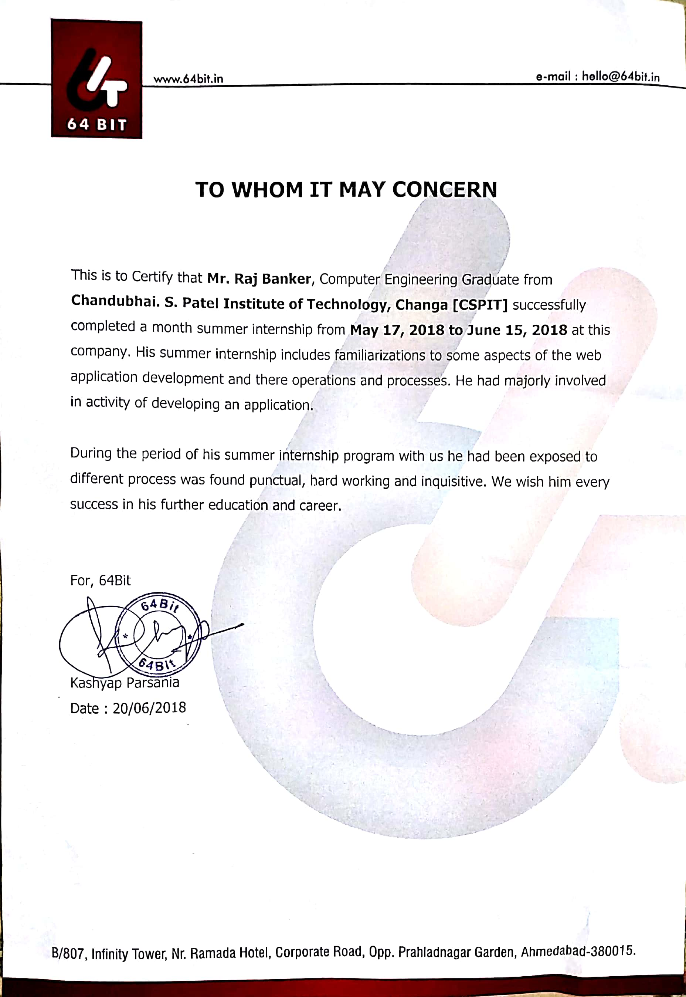

**Accredited with Grade A by NAAC**

**Accredited with Grade A by KCG**

**CERTIFICATE**

This is to certify that the report entitled “**Live Chat**” is a bonafied work carried out by **Raj Banker (16IT003)** under the guidance and supervision of **Mr.** **Parvez Vanitya** for the subject **Summer Intership-1 (IT346)** of 5th Semester of Bachelor of Technology in **Information Technology** at Chandubhai S. Patel Institute of Technology (CSPIT), Faculty of Technology & Engineering (FTE) – CHARUSAT, Gujarat.

To the best of my knowledge and belief, this work embodies the work of candidate themselves, has duly been completed, and fulfills the requirement of the ordinance relating to the B.Tech. Degree of the University and is up to the standard in respect of content, presentation and language for being referred by the examiner(s).

|  |  |
| --- | --- |
| Under the supervision of,  Mr. Parvez Vantiya  General Manager  64 BIT |  |
| Dr. Parth Shah  Head -Department of Information Technology,  CHARUSAT, Changa, Gujarat. | |

**Chandubhai S. Patel Institute of Technology (CSPIT)**

**Faculty of Technology & Engineering (FTE), CHARUSAT**

At: Changa, Ta. Petlad, Dist. Anand, Pin:388421. Gujarat.

**ACKNOWLEDGEMENT**

We have taken efforts in this project. However, it would not have been possible without the kind support and help of many hands. I would like to extend my sincere thanks to all of them.

We are highly indebted to **Mr. Pinal Shah** for his guidance and constant supervision as well as for providing necessary information regarding the project & also for his support in completing the project.

We are grateful to our external guide **Mr. Parvez Vantiya** and **Mr. Yogesh Barot** in 64 BIT for giving me the support and encouragement that was necessary for the completion of this project.

We would like to express my gratitude to **H.O.D. Mr. Parth Shah** and We are also grateful to all my faculty members of Chandubhai S Patel Institute of Technology for their kind co-operation and encouragement which help me in completion of this project and preparing the report.

Last but not the least, I would also like to thank my colleagues, who have co- operated during the preparation of my report and without them this project has not been possible. Their ideas helped me a lot to improve my project report.

**“We may not achieve everything we dream, but we cannot achieve anything unless we dream.”**

**Raj Banker (16IT003)**

**Chirag Patel(16IT065)**

**Abstract**

To ensure that a customer is satisfied when they purchase a product, they need to be able to receive assistance if the product does not work correctly or is in any other way unsatisfactory. This is why support is needed. There are many different types of support, but with an ever growing number of people having less time to spare in their everyday life, a quick short answer is sometimes preferred. This is why the market for Live-Chat support solutions has grown.

Live Chat is a real-time, live-chat software tool that helps e-commerce companies create a new sales channel by offering a superior online support. What better way to offer them help than through a quick chat on your website? It’s way faster than email and more efficient than phone. This project was developed using the programming language PHP, with additional functionality developed in jQuery, AJAX, HTML and CSS.

TABLE OF CONTENTS

Acknowledgement viii

Abstract ix

List Of Figures xi

List Of Tables xii

Company Profile 1

Chapter 1

Introduction 3

Overview 3

Chapter 2

Problem Statement 4

Chapter 3 Solution 5

Android 5

System Planning 8

Implementation and Testing 11

Snapshots 12

Chapter 4 Conclusions 29

References 30

LIST OF FIGURES

Figure 3-1Index Page 4

Figure 3-2.1 Popup Window 6

Figure 3-2.2 Customer Side Panel 12

Figure 3-3 Agent Login Screen 13

Figure 3-4 Getting Started Agent Side 14

Figure 3-5 Replying to Customer 15

Figure 3-6User Agent Chat 16

Figure 3-7 Admin Login 17

Figure 3-8 Admin Panel 18

Figure 3-9 Add Agents 19

Figure 3-10 View Agents 20

Figure 3-11 Discussions 21

Figure 3-12 Posted Chat 22

Figure 3-12 Session Management 22

**COMPANY PROFILE**

64 Bit is a leading Indian web design agency, based out of Gujarat. Apart from website design, app development, UI and UX design, they have been focusing on offering bespoke online solutions for our clients, encompassing all kinds of online marketing and SEO efforts. They strongly believe that brands can be created with right efforts, and we aim the same for all clients who are looking for an online edge.

They started off on a small scale, but with their extended team and the expertise of the top management, they have emerged as one of the leading names in the web world. They don’t just create designs and apps, but their focus is to offer genuine backing for clients, both in short and long run. Over the past decades, they have created some amazing websites and apps, which stand as a trademark of success and speak volumes about customization and aesthetics. They also have dedicated branches that look into the requirements of current content management systems and ecommerce industry, while also focusing on many other aspects of online marketing.

SEO, social media marketing, and paid marketing also remain their priorities, as they are committed to offering all options for new and budding brands and businesses. At any given point of time, they are always beaming with ideas, which are customized and effectively tailored for our customers.

**Services Provided :-**

* Web Design
* Web Development
* Mobile Apps
* Software Development
* Internet Marketing

**Details Related to company:**

Address :411 Arista ,Opp. HOF Showroom,

Nr. Armeida, Sindhu Bhavan Road,

Bodakdev,Ahmedabad – 380054

Spread : No Other Branches.

Number of Employees :- 7 (including Designers , Developers , Manager).

Division of Company :- Marketing and IT

Group and Division :- As a PHP developer in IT division.

**CHAPTER 1**

**INTRODUCTION**

**Overview**

**“LiveChat”** is a module for websites which allows interaction of customers and agent of the website. This is basically used to provide instant support to the customer. Customers queries can be solved immediately by the agent so they can make meaningful decision. Firstly customer will have to submit his name and email in the module then he/she will have to select a topic of query like it is technical or non-technical Then he/she will have to type the message then after sending the message agent will be notified about the user and then according to message agent can reply to the customer. Agent are created by the admin user. Only verified users can login through login page of agent and can reply to the customer. If customer doesn’t do any activity in 10 minutes he/she will be disconnected from the LiveChat. Customer will be displayed offline in agent panel so agent can know that customer is offline and agent can communicate to another customer. If customer is disconnected then he/she will have to enter the details again but chat will be stored so he/she doesn’t have to worry about the previous conversation with the agent.

**CHAPTER 2**

**SYSTEM ANALYSIS**

**2.1 User Characteristics**

* Our System is very easy to use for both the client and the agents on the admin side.
* No other specific expertise is required.

**2.2 Tools and Technology**

**2.2.1 Technology**

* **HTML**

Webpages are written in HTML - a simple scripting language.HTML is short for Hyper Text Markup Language. Hypertext is simply a piece of text that works as a link. Markup Language is a way of writing layout information within documents.

Basically an HTML document is a plain text file that contains text and nothing else.    
When a browser opens an HTML file, the browser will look for HTML codes in the text and use them to change the layout, insert images, or create links to other pages. Since HTML documents are just text files they can be written in even the simplest text editor. A more popular choice is to use a special HTML editor - maybe even one that puts focus on the visual result rather than the codes - a so-called WYSIWYG editor ("What You See Is What You Get"). Some of the most popular HTML editors, such as FrontPage or Dreamweaver will let you create pages more or less as you write documents in Word or whatever text editor you're using.

* **CSS**

Cascading Style Sheets, fondly referred to as CSS, is a simple design language intended to simplify the process of making web pages presentable.

CSS handles the look and feel part of a web page. Using CSS, you can control the color of the text, the style of fonts, the spacing between paragraphs, how columns are sized and laid out, what background images or colors are used, layout designs, variations in display for different devices and screen sizes as well as a variety of other effects.CSS is easy to learn and understand but it provides powerful control over the presentation of an HTML document. Most commonly, CSS is combined with the markup languages HTML or XHTML.

**Advantages of CSS**

CSS saves time − You can write CSS once and then reuse same sheet in multiple HTML pages. You can define a style for each HTML element and apply it to as many Web pages as you want.

Pages load faster − If you are using CSS, you do not need to write HTML tag attributes every time. Just write one CSS rule of a tag and apply it to all the occurrences of that tag. So less code means faster download times.

Easy maintenance − To make a global change, simply change the style, and all elements in all the web pages will be updated automatically.

Superior styles to HTML − CSS has a much wider array of attributes than HTML, so you can give a far better look to your HTML page in comparison to HTML attributes.

Multiple Device Compatibility − Style sheets allow content to be optimized for more than one type of device. By using the same HTML document, different versions of a website can be presented for handheld devices such as PDAs and cell phones or for printing.

Global web standards − Now HTML attributes are being deprecated and it is being recommended to use CSS. So it’s a good idea to start using CSS in all the HTML pages to make them compatible to future browsers.

Offline Browsing − CSS can store web applications locally with the help of an offline cache. Using of this, we can view offline websites. The cache also ensures faster loading and better overall performance of the website.

Platform Independence − The Script offer consistent platform independence and can support latest browsers as well.

* **JAVASCRIPT**

JavaScript is a cross-platform, object-oriented scripting language used to make webpages interactive (e.g. having complex animations, clickable buttons, popup menus, etc.).  There are also more advanced server side versions of javascript such as Node.Js which allow you to add more functionality to a website than simply downloading files (such as realtime collaboration between multiple computers). Inside a host environment (for example, a web browser), JavaScript can be connected to the objects of its environment to provide programmatic control over them.

JavaScript contains a standard library of objects, such as Array, Date, and Math, and a core set of language elements such as operators, control structures, and statements. Core JavaScript can be extended for a variety of purposes by supplementing it with additional objects; for example:

Client-side JavaScript extends the core language by supplying objects to control a browser and its Document Object Model (DOM). For example, client-side extensions allow an application to place elements on an HTML form and respond to user events such as mouse clicks, form input, and page navigation.

Server-side JavaScript extends the core language by supplying objects relevant to running JavaScript on a server. For example, server-side extensions allow an application to communicate with a database, provide continuity of information from one invocation to another of the application, or perform file manipulations on a server.

This means that in the browser, JavaScript can change the way the webpage (DOM) looks. And, likewise, Node.js JavaScript on the server can respond to custom requests from code written in the browser

* **jQuery**

jQuery is an open source JavaScript library that simplifies the interactions between an HTML/CSS document, or more precisely the Document Object Model (DOM), and JavaScript.  
Elaborating the terms, jQuery simplifies HTML document traversing and

manipulation, browser event handling, DOM animations, Ajax interactions, and cross-browser JavaScript development.  
Note: The only library available today that meets the needs of both designer types and programmer types is jQuery.

**Why jQuery?**

**Some of the key points which supports the answer for why to use jQuery:**

* It is incredibly popular, which is to say it has a large community of users and a healthy amount of contributors who participate as developers and evangelists.
* It normalizes the differences between web browsers so that you don’t have to.
* It is intentionally a lightweight footprint with a simple yet clever plugin architecture.
* Its repository of plugins is vast and has seen steady growth since jQuery’s release.
* Its API is fully documented, including inline code examples, which in the world of JavaScript libraries is a luxury. Heck, any documentation at all was a luxury for years.
* It is friendly, which is to say it provides helpful ways to avoid conflicts with other JavaScript libraries.
* There are several ways to start using jQuery on your web site.
* Use the Google-hosted/ Microsoft-hosted content delivery network (CDN) to include a version of jQuery.
* Download own version of jQuery from jQuery.com and host it on own server or local filesystem.

* **Ajax**

Ajax refers to JavaScript and XML, technologies that are widely used for creating dynamic and asynchronous web content. While Ajax is not limited to JavaScript and XML technologies, more often than not they are used together by web applications. The focus of this tutorial is on using JavaScript based Ajax functionality in JavaServer Faces web applications.

JavaScript is a dynamic scripting language for web applications. It allows users to add enhanced functionality to user interfaces and allows web pages to interact with clients asynchronously. JavaScript runs mainly on the client side (as in a browser) and thereby reduces server access by clients.

When a JavaScript function sends an asynchronous request from the client to the server, the server sends back a response that is used to update the page’s

Document Object Model (DOM). This response is often in the format of an XML document. The term **Ajax** refers to this interaction between the client and server.

The server response need not be in XML only; it can also be in other formats, such as [JSON](http://www.json.org/). This tutorial does not focus on the response formats.

Ajax enables asynchronous and partial updating of web applications. Such functionality allows for highly responsive web pages that are rendered in near real time. Ajax-based web applications can access server and process information and can also retrieve data without interfering with the display and rendering of the current web page on a client (such as a browser).

Some of the advantages of using Ajax are as follows:

* Form data validation in real time, eliminating the need to submit the form for verification
* Enhanced functionality for web pages, such as user name and password prompts
* Partial update of the web content, avoiding complete page reloads
* **SQL**

SQL is Structured Query Language, which is a computer language for storing, manipulating and retrieving data stored in a relational database.

SQL is the standard language for Relational Database System. All the Relational Database Management Systems (RDMS) like MySQL, MS Access, Oracle, Sybase, Informix, Postgres and SQL Server use SQL as their standard database language.

**SQL is widely popular because it offers the following advantages −**

* + Allows users to access data in the relational database management systems.
  + Allows users to describe the data.
  + Allows users to define the data in a database and manipulate that data.
  + Allows to embed within other languages using SQL modules, libraries & pre-compilers.
  + Allows users to create and drop databases and tables.
  + Allows users to create view, stored procedure, functions in a database.
  + Allows users to set permissions on tables, procedures and views.
* **PHP**

PHP started out as a small open source project that evolved as more and more people found out how useful it was. Rasmus Lerdorf unleashed the first version of PHP way back in 1994. PHP is a recursive acronym for "PHP: Hypertext Preprocessor".

PHP is a server side scripting language that is embedded in HTML. It is used to manage dynamic content, databases, session tracking, even build entire e-commerce sites. It is integrated with a number of popular databases, including MySQL, PostgreSQL, Oracle, Sybase, Informix, and Microsoft SQL Server. PHP is pleasingly zippy in its execution, especially when compiled as an Apache module on the Unix side. The MySQL server, once started, executes even very complex queries with huge result sets in record-setting time. PHP supports a large number of major protocols such as POP3, IMAP, and LDAP. PHP4 added support for Java and distributed object architectures (COM and CORBA), making n-tier development a possibility for the first time. PHP is forgiving: PHP language tries to be as forgiving as possible.

**Common uses of PHP :-**

* PHP performs system functions, i.e. from files on a system it can create, open, read, write, and close them.
* PHP can handle forms, i.e. gather data from files, save data to a file, through email you can send data, return data to the user.
* You add, delete, modify elements within your database through PHP.
* Access cookies variables and set cookies.
* Using PHP, you can restrict users to access some pages of your website.
* It can encrypt data.

**Characteristics of PHP :-**

* Simplicity
* Efficiency
* Security
* Flexibility
* Familiarity

**2.2.2 Database**

* MYSQL

**2.2.3 Software Requirements**

* A Computer which can run any browser is enough to run this module.

**2.2.4 Hardware Requirements**

* Same as requirements of any browser.

**SNAPSHOTS**

Below are the snapshots on which we have worked on during the Summer Internship.

**Index Page of Live Chat application**

This screen is the index page. Basically it is divided into three modules. There is Customer Panel for customers, Agent panel for the agents from which agent will communicate to users and admin panel for the admin which will be used by admin.

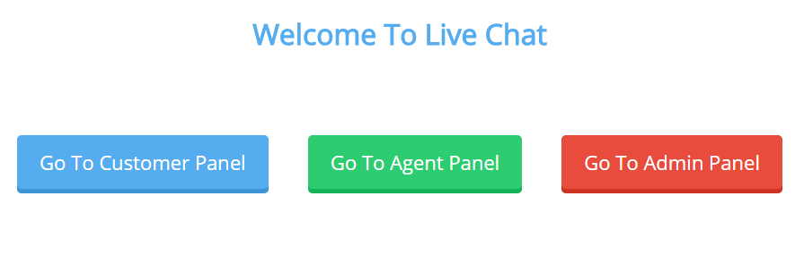

**Figure 3-1 Index Page**

**Customer Panel**

Below are the snapshots of the Customer panel through which the customer can send a message by entering details like Name, Subject and email-id.



**Figure 3-2.1 Popup Window**

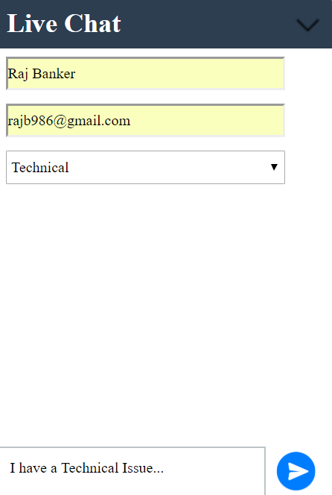

**Figure 3-2.2 Customer Side Panel**

**Sign in Page of Agent**

Whenever an agent wants to start communicating with the clients He/She hase to first login through this portal and after successful login of the agent he/she can start communicating with the clients. Agent Name and email-id are registered by the admin so only authorised agents can login from here.

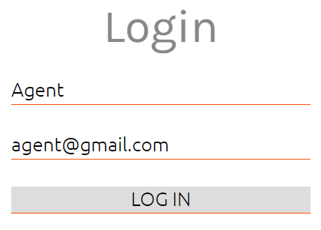

**Figure 3-3 Agent Login Screen**

**Getting Started Agent side**

After Successful Login of agent from the login portal they are directed to this page where the agent can see the list of customers and the customers which are online of offline.

Clicking on any specific customer will show the messages sent by the user along with the date and time and then the agent can start communicating with the customer and solve their problems, doubts or any questions regarding your product.

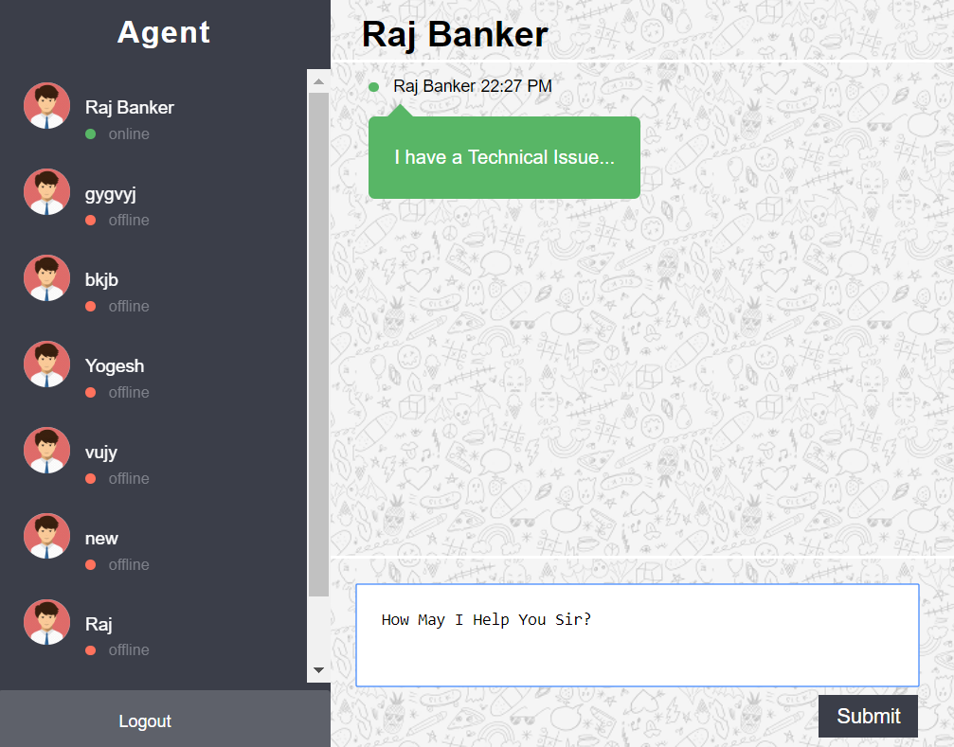

**Figure 3-4 Getting Started Agent Side**

**Replying to customer**

When agent selects the customer to communicate with it will display the message of user and he/she can reply to it and user will come to know about it.

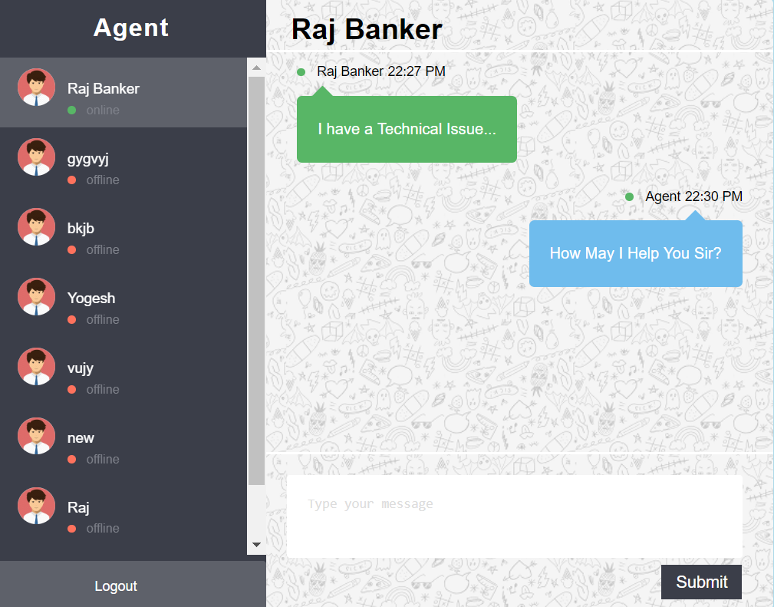

**Figure 3-5 Replying to customer**

**User-Agent Chat on Client Side**

This is a snapshot after the customer starts having conversation with the agent . Different colors are used for both the messaged received from the agent and the messages sent by the user which separates both messages and helps in giving an attractive look to the user screen. Also we have provided a minimize button which will minimize the chat window soo that the user while waiting for the agent’s reply can go through the website and have a look at different products from the website.

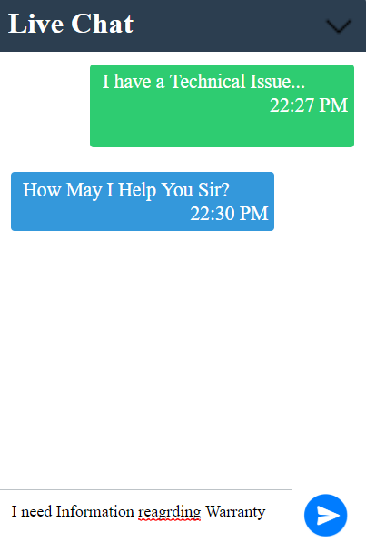

**Figure 3-6 User Agent Chat**

**Admin Login**

This is the Login Page for the Admin only. The Admin can login here using username and password and upon the successful login of the admin he/she will be redirected to other page as shown below in Fig 3-8. After admin has logged in he/she can view the list of all the agents, add agents or see the conversation of their clients with the agents.

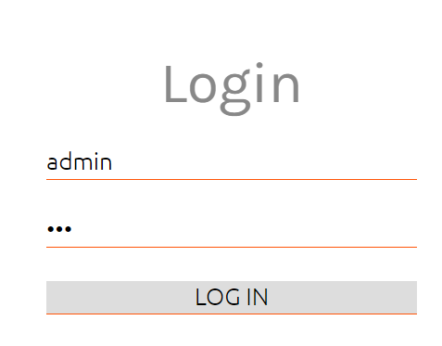

**Figure 3-7 Admin Login**

**Admin Home Page**

This is how the admin panel looks after admin is logged in. Three options are available for the admin. The first option Add Agents is used to add the details of their new agents in the system soo that he/she can also start communicating with the customers. The Second is View Agents which display the list of all the agents as shown in Fig 3-10 enrolled in their system and the third option is for the discussion panel which shows the chat of the customers with their agents.

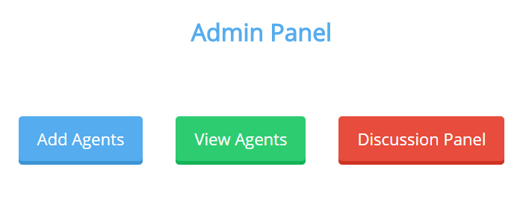

**Figure 3-8 Admin Panel**

**Add Agents**

Here the admin has to enter details of their new agent which the agent can use to login on the agent login panel and start chatting with the customers.

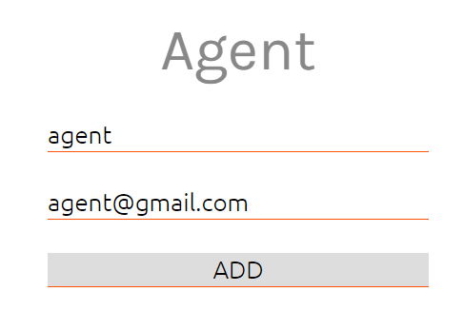

**Figure 3-9 Add Agents**

**View Agents**

Here the admin can view the list of all of his agents that communicate with the Clients in a tabular form.

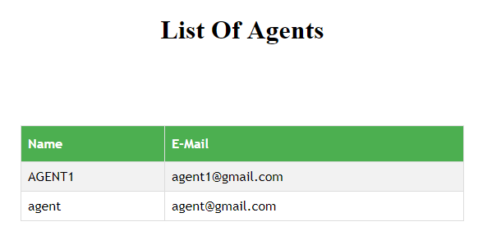

**Figure 3-10 View Agents**

**Discussion Panel**

This is the Discussion panel which shows the discussions between client and agent.

Here the discussions are separated on the basis of the Subject of the Discussion. Here the first message by the user is used as the display message in the discussion page as the first message of the user gives a clear-cut idea about any doubts or problem faced. Clicking Upon that display message ,the admin will be redirected to a different page as shown in Fig 3-12 where the admin can see whole discussion done between the customer and agent.

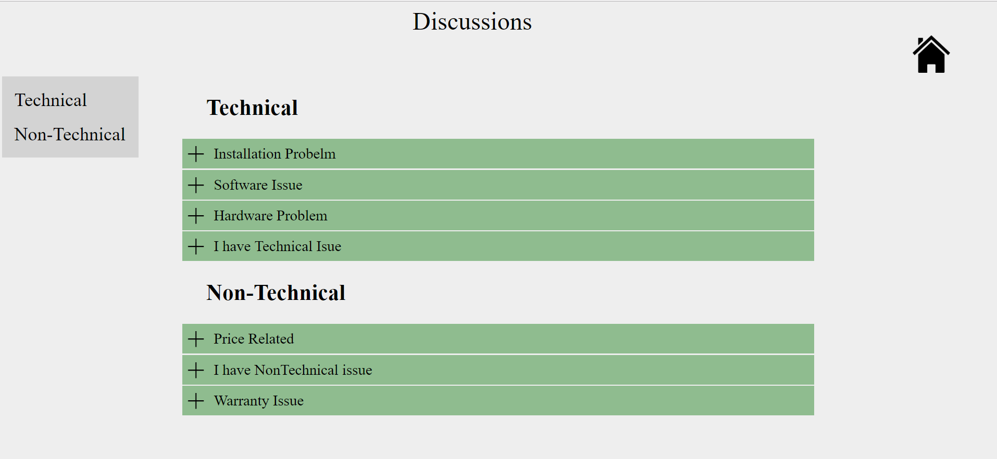

**Figure 3-11 Discussions**

**Posted Chat**

When admin clicks on message it will open the posted chat between agent and customer.

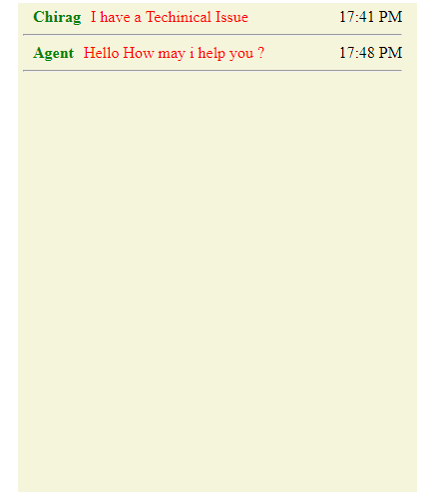

**Figure 3-12 Posted Chat**

**Session Management**

If User Doesn’t reply in particular time he/she will be disconnected and will have to fill again the details again.

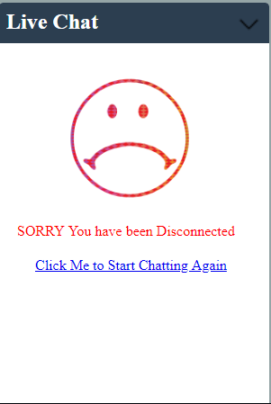

**Figure 3-13 Session Management**